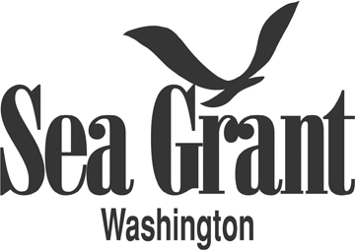
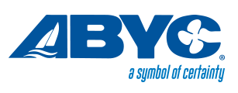
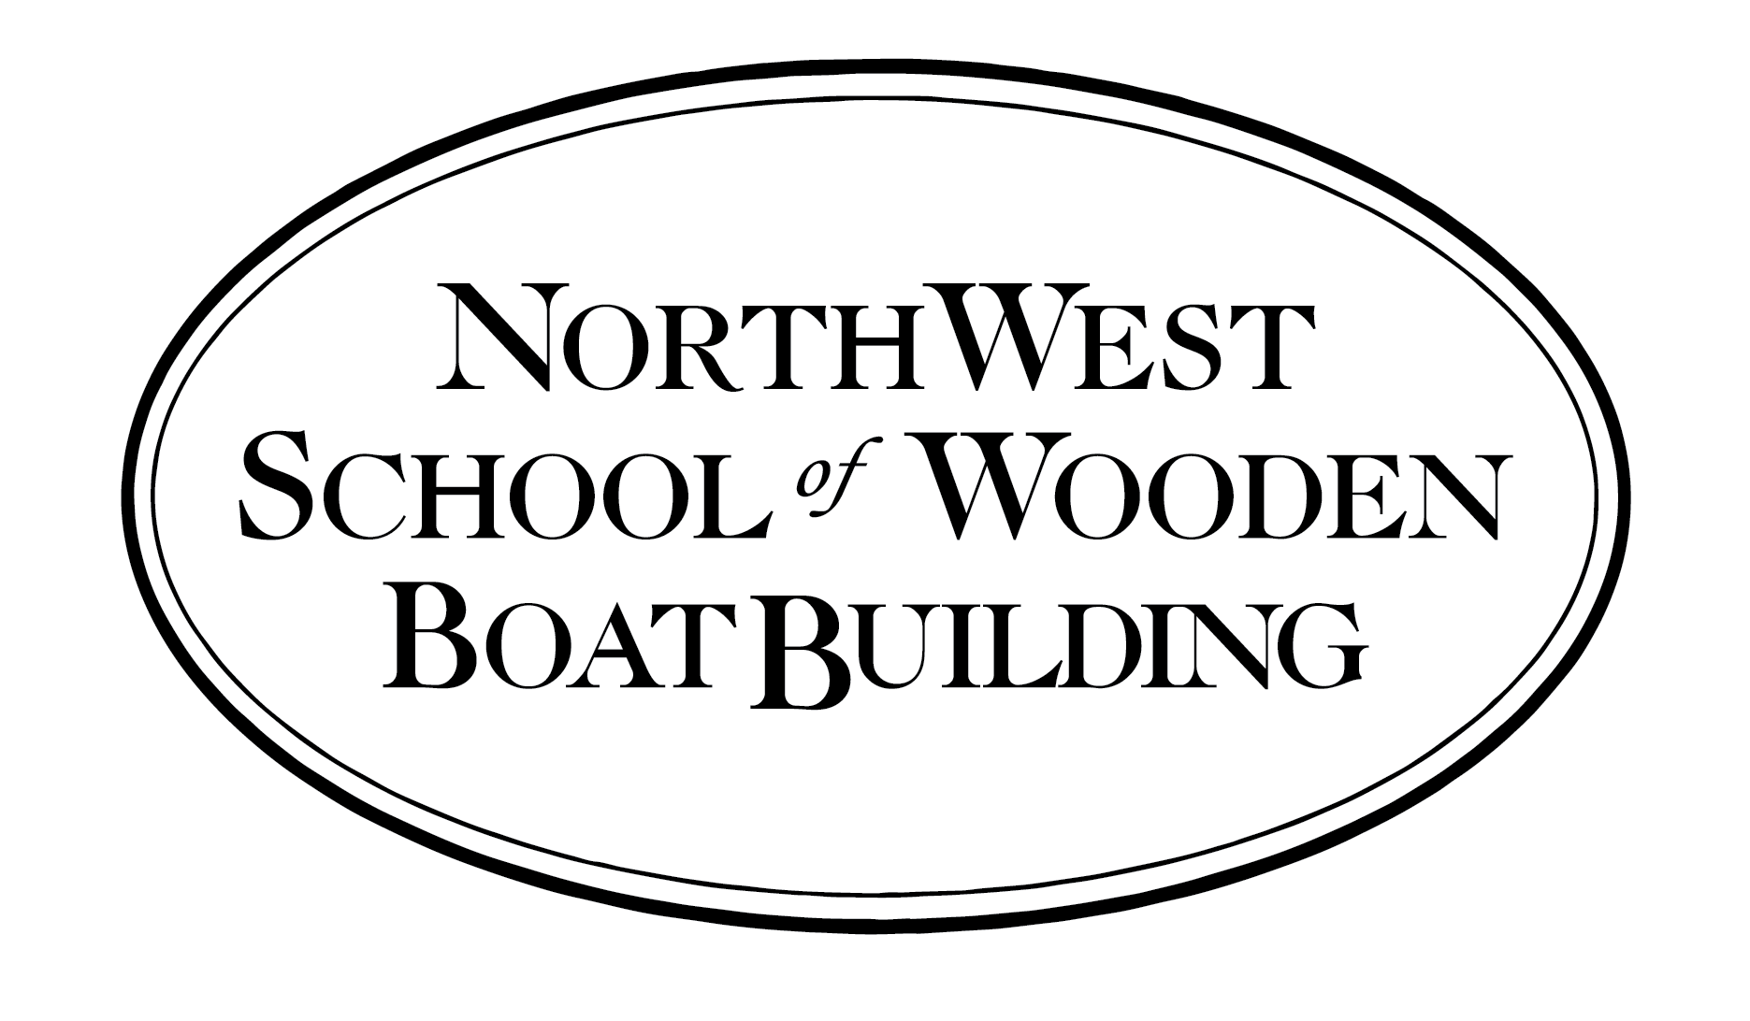

FOR IMMEDIATE RELEASE
July 20, 2016

MEDIA CONTACTS:
Betsy Davis, Northwest School of Wooden Boatbuilding
360.385.4948 or betsy@nwswb.edu

Sandy Brown, American Boat and Yacht Council
410.990.4460 ext. 101 or sbrown@adycinc.org

ABYC Basic Marine Electrical and Corrosion Mitigation
Course to be Offered Fall 2016

September 19-22, 2016

Learn to handle marine electrical systems and corrosion prevention for both salt and
fresh water environments

Port Hadlock, WA –The Northwest School of Wooden Boatbuilding is hosting a four-day training on fundamental marine electrical systems September 19-22, with support from Washington Sea Grant. The course will be taught by the American Boat and Yacht Council (ABYC), the leader in technical education and technical certification in the marine industry

This class is essential for anyone dealing with marine electrical systems and safety issues. Instructor Kevin Ritz will provide a core foundation of technical information for both salt and fresh water marine environments. The program will explain common terms and discuss fundamental electrical theory as it applies to marine electrical systems and cathodic protection systems used to help mitigate corrosion on boats.

Students will learn how to use a common digital multi-meter to measure volts, electrical resistance and amperage, both AC and DC, and how to interpret the readings to inform corrective actions. The course will also cover marine corrosion causes, testing, and prevention.

Online registration for the course is available until September 9, 2016. Course materials will be handed out during the first day of class. Students with special needs should notify ABYC in writing at the time of registration so that special accommodations can be made.

When: Monday, September 19 - Thursday September 22, 2016 at 8:30 a.m.

Where: Northwest School of Wooden Boat Building
Port Hadlock Heritage Campus
42 N. Water Street
Port Hadlock, Washington 98339

Fee: $700.00 ABYC Members, $985.00 Non-member

To register or for more information go to http://abycinc.org/events/EventDetails.aspx?id=777921&group=

The Northwest School of Wooden Boatbuilding’s mission is to teach and preserve traditional and contemporary wooden boatbuilding skills while developing the individual as a craftsman. For over 35 years the school’s experienced instructors have provided hands-on training in new construction and repair. Find out more at www.nwswb.edu or https://www.facebook.com/NWBoatSchool .

Washington Sea Grant, based at the University of Washington, provides statewide research, outreach, and education services addressing the challenges facing our ocean and coasts. The National Sea Grant College Program is part of the National Oceanic and Atmospheric Administration, U.S. Department of Commerce. www.wsg.washington.edu. Join the conversation: @WASeaGrant and Facebook.com/WaSeaGrant.

Since 1954, the nonprofit American Boat & Yacht Council (ABYC) has developed safety standards for boat design, construction, equipage, repair and maintenance. ABYC is the premier global standards organization in the marine industry and a leader in technical education and technician certification. Visit www.abycinc.org

