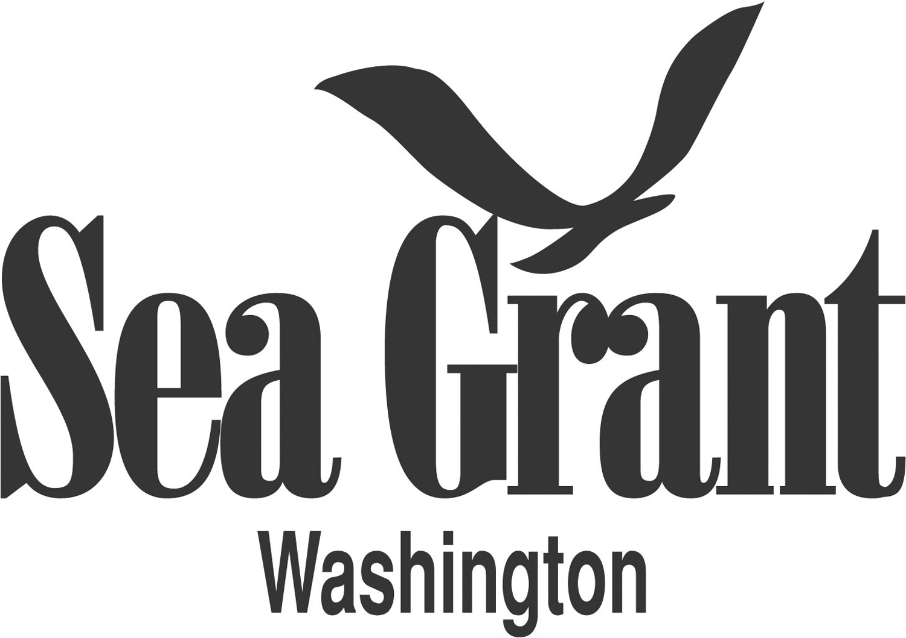

FOR IMMEDIATE RELEASE
August 17, 2015

CONTACTS: Sarah Fisken, WSG Continuing Education
206.543.1225 or sfisken@u.washington.edu
MaryAnn Wagner, WSG Communications
206.616.6353 or maryannb@uw.edu

Marine Weather Workshop
Sat., Oct. 3, 9 a.m. – 3 p. m. in Port Townsend

Stay Safe on the Water
Sign up for a one-day Marine Weather Workshop for anyone who lives or works on the water.

WHAT: A one-day, all-inclusive Marine Weather Workshop taught by marine weather experts Jay Albrecht and Dave Wilkinson, will prepare boaters for safety on Northwest waters, whichever way the wind may blow. The workshop is co-sponsored by Washington Sea Grant, Northwest Maritime Center, and WSU Jefferson County Extension. The workshop will be held in Port Townsend’s Northwest Maritime Center. Topics covered will include:

- Relationships of atmospheric pressure and wind
- Determining the path and speed of squalls
- Strong wind systems found in the Northwest and offshore; how to avoid them
- Key features of low pressure systems
- How 500mb wind patterns can help you find “weather windows” for safe passages
- How do pressure gradients affect wind in Washington waters
- What is a computer model? How do they work and what they can give you
- How to get Northwest Weather Service and associated weather, forecast and model data on your computer

WHO: Boaters, fishermen, kayakers, and anyone else on the water can benefit from this workshop.

WHEN: Sat., Oct. 3, 2015
9 a.m. to 3 p.m.

WHERE: NW Maritime Center
431 Water Street
Port Townsend, WA

PRICE: $80; pre-registration is required.

To register or for more information, contact Sarah Fisken, sfisken@uw.edu or 206.543.1225.

# # #

Washington Sea Grant, based at the University of Washington, provides statewide marine research, outreach, and education services – helping people to understand and address the challenges facing Washington’s oceans and coasts. The National Sea Grant College Program is part of the National Oceanic and Atmospheric Administration, U.S. Department of Commerce. www.wsg.washington.edu

Join the conversation with Twitter @WASeaGrant and Facebook.com/WaSeaGrant

