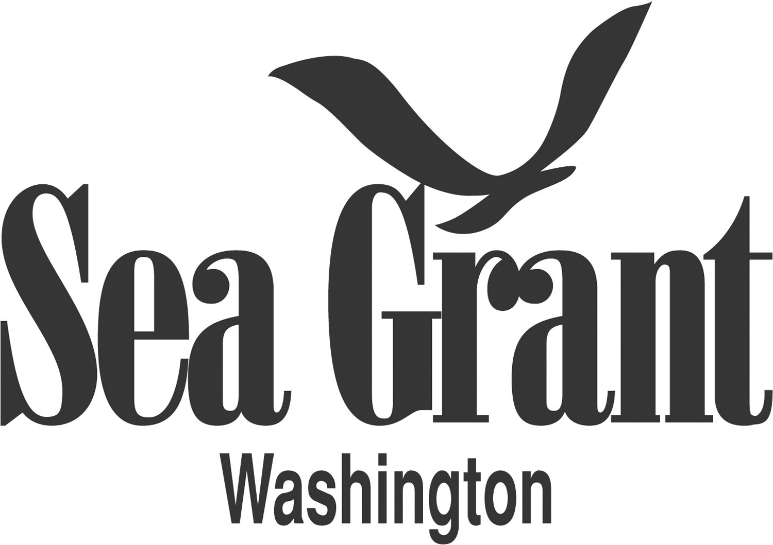

NEWS RELEASE
FOR IMMEDIATE RELEASE
July 22, 2016
CONTACT: Maile Sullivan, Washington Sea Grant
206-543-2822 or noaacamp@uw.edu

MaryAnn Wagner, Washington Sea Grant
206-371-7656 or maryannb@uw.edu

NOAA Summer Science Camp Pilots ROV Intensive Workshop

Middle School students get hands-on experience designing and building tiny robots.

Seattle - Washington Sea Grant and NOAA are partnering with Atlantis STEAM to pilot for the first time a two-day Remotely Operated Vehicle (ROV) workshop during NOAA’s summer science camp for middle school students.

During the ROV mini-session, students will have the rare opportunity to design, build and maneuver their very own ROVs, while also learning about real-world ROV applications. ROVs are unoccupied underwater robots used increasingly in a wide variety of marine industry and research applications, such as studying undersea volcanoes or installing sensors on the sea floor. They are connected to a vessel by cables that transmit information, allowing the robot to be remotely navigated by someone on-board the ship.

Hannah McConnaughey, a University of Washington undergraduate student and Atlantis STEAM cofounder, designed the ROV program. “This will be many students’ first introduction to ROV technology,” says McConnaughey. “Hands-on science is great because it’s something students are excited about can interact with personally and has real world applications.” McConnaughey has been building ROVs competitively since she was in middle school. Atlantis STEAM, an offshoot of McConnaughey’s all-girl high school robotics team from South Whidbey Island, focuses on hands-on science education and encouraging gender equality in STEM fields.

During the two-day workshop, students will create a mini-ROV capable of simple tasks. This includes developing technical skills, such as soldering, wiring switches, building a control panel and hooking up the motor. They will also learn concepts of buoyancy, thrust and electricity. The workshop is also a place where students will learn how to deal with failures without getting discouraged by troubleshooting and problem solving. “Science and failure are a hand in hand deal, the important thing is that you keep persevering and learning.”

For more information, contact Washington Sea Grant Education Specialist Maile Sullivan, 206-543-2822 or noaacamp@uw.edu.

Washington Sea Grant, based at the University of Washington, provides statewide research, outreach, and education services addressing the challenges facing our ocean and coasts. The National Sea Grant College Program is part of the National Oceanic and Atmospheric Administration, U.S. Department of Commerce. www.wsg.washington.edu. Join the conversation: @WASeaGrant and Facebook.com/WaSeaGrant.

